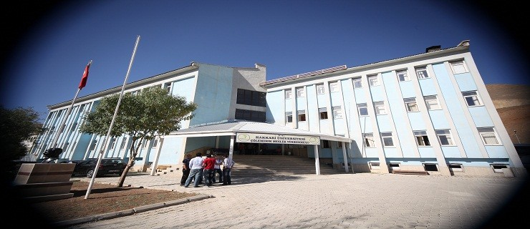

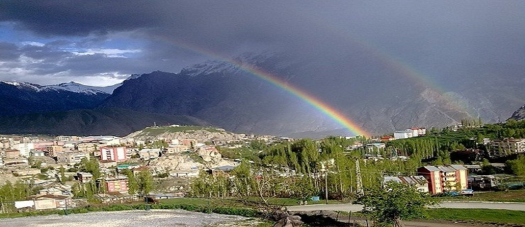





**HAKKARI UNIVERSITY SCHOOL OF FOREIGN LANGUAGES - 2018**

ACTIVITY REPORT

2

## TABLE OF CONTENTS

1. ***GENERAL INFORMATION***

***A- Mission and Vision B- Our Goal***

***C- INFORMATION ON ADMINISTRATION 1- PHYSICAL STRUCTURE***

***1.1. Offices***

1. ***ORGANIZATIONAL STRUCTURE***
2. ***INFORMATION AND TECHNOLOGICAL RESOURCES***
   1. ***Software and Computers 4- HUMAN RESOURCES***
   2. ***.Administration Staff***
   3. ***.Educational Status of Administrative Personnel***
   4. ***Service Periods of Administrative Staff***
   5. ***Distribution of Administrative Personnel by Age 5- SERVICES OFFERED***

***5.1. Education Services 5.1.1- Number of Students***

***5.1.2- Student Quotas***

***5.1.3- Foreign Students***

***6- MANAGEMENT AND INTERNAL CONTROL SYSTEM***

***D- Other Considerations***

1. ***PURPOSE and OBJECTIVES***

***A- AIMS AND OBJECTIVES OF THE ADMINISTRATION***

***B- BASIC POLICIES AND PRIORITIES C- OTHER CONSIDERATIONS***

1. ***EVALUATION OF CORPORATE CAPABILITY AND CAPACITY***

***A- Superiorities B- Weaknesses***

***C- Assessment***

1. ***RECOMMENDATIONS AND TREATMENTS***

***Internal Control Assurance Statement***

3

# UNIT / SENIOR MANAGER PRESENTATION

The most important of the essential conditions of modern life is to be able to use a foreign language in the best way for both professional and personal purposes. Hakkari University School of Foreign Languages aims to allow each student to teach and use at least one language, including professional and academic English, in line with this goal. For this purpose, it educates the faculty members in vocational and academic English teaching, and also updates the contents of the courses according to the characteristics of the programs and vocational fields by continuously following the literature in the field of foreign language education.

The School of Foreign Languages carries out general and vocational foreign language education in all undergraduate and associate degree programs of our university. In line with this point, our main goal as the School of Foreign Languages is to provide environments that will enable our students to learn the English they will need in their national and international academic and business lives effectively and functionally.

# Assist. Professor Erdal BINGÖL Academy Deputy Manager

* 1. **GENERAL INFORMATION**
     1. **Mission and Vision**

***MISSION:***

- It is a one-year training program aimed at helping students develop the necessary feelings of knowledge, skills and trust in professional and social circles, and to use and develop the target language effectively throughout their academic studies.

-To carry out highly qualified education, training and scientific research.

-To raise educated, highly knowledgeable individuals

-To lead social, cultural and economic development of our region

The continuous goal of our school is to be a unit of Hakkari University that provides education and training in Hakkari province in the best way, both academically and socially, as well as to prepare young minds for life to capture rapidly changing global orientations.

***VISION***:

To be a modeled, preferred, contemporary and respected school that conducts quality education and universal research in the field of education. Accordingly, our mission is; to provide a solid foreign language infrastructure that our students will need during and after their undergraduate studies by improving their oral and written communication skills in a foreign language.

## Our Values:

* Responsibility Awareness
* Being Respectful
* Creativity – Innovation
* Being a Participant
* Being Open to Collaboration
* Student Satisfaction
* Employee Satisfaction
* Environment Awareness

# Our Objective

To educate talented, highly skilled individuals who are equipped with contemporary knowledge, who have the qualities that the sector needs and seeks, and to allow them to contribute to the emerging and changing world criteria in the field of foreign languages.

## Duties and Responsibilities of the School of Foreign Languages:

1. To carry out procedures related to the admission and course status of the students,
2. To provide certificate to our students studying Elective Preparatory Class,
3. Providing the necessary social services to the students, ensuring the necessary coordination and control in order to carry out them efficiently,
4. Fulfillment of other similar tasks to be given.
5. Ensuring curriculum unity and coordination within the university and among similar programs within the regional universities.

## The principles that we will be based on in our work are:

* + - To Respect Human Rights,
  + - To Highlight Human Relations,
  + - To Provide Quality Service using time well,
  + - To Have an Ethical Understanding,
  + - To Be Open to Technological Development,
  + - To Use Resources Effectively Without Wasting,
  + - To Develop Service Understanding and Being Effective in the Field of Application.

## OBJECTIVE OF OUR SCHOOL :

* + To bring with realization activities that will contribute to the sustainable development of the region,
  + To meet all fixture equipment and laboratory needs of our university units,
  + Improving technological equipment in classrooms, libraries and other indoor areas
  + To open new departments and programs by strengthening the academic staff and to improve the quality of education and training.

# INFORMATION ABOUT the ADMINISTRATION

## Physical Structure

1.1. ***Offices***

|  |  |  |  |
| --- | --- | --- | --- |
| **Educational Field** | **Classroom** | **Laboratory** | **Perimeter Area** |
| 100 Sqm | 2 | 0 | 19,000 Sqm |

## Social Areas

|  |  |  |  |
| --- | --- | --- | --- |
|  | **Qty** | **Area (sqm)** | **Capacity** |
| Student and Staff Dining Hall (owned by ÇMYO) | 2 | 450 Sqm | 300 |
| Canteen/Cafeterias (ÇMYO) | 1 | 100 Sqm | 50 |
| **Total** | **3** | **550 Sqm** | **350** |

***Service Zones***

|  |  |  |  |
| --- | --- | --- | --- |
|  | **Number of Offices** | **Area (sqm)** | **Number of Personnel** |
| Administration Staff | 3 | 20 | 4 |
| Academic Personnel | 1 | 12 | 12 |
| **Total** | **4** | **32** | **16** |

***Warehouse and Archive Fields***

|  |  |  |
| --- | --- | --- |
|  | **Quant.** | **Area (sqm)** |
| Storehouse | 1 | 20 |
| **Total** | **1** | **20** |

***Technological Resources***

|  |  |  |
| --- | --- | --- |
|  |  |  |
| Desktop Computer | 5 | 5 |
| Laptop | 16 | 16 |
| **Total** | **21** | **21** |

**2016 Undergraduate Transfer and Special Student**

|  |  |  |
| --- | --- | --- |
|  | **Incoming** | **Outgoing** |
| Undergraduate Transfer | 0 | 0 |
| Special Student | --- | --- |
| **Total** | **0** | **0** |

**2017 Disenrolled**

|  |  |  |
| --- | --- | --- |
|  |  |  |
| Disenrolled Students | **4** | 4 |

# 2- Organization Structure

# Organization Structure of The School of Foreign Languages

Director of the School

|  |  |  |  |  |
| --- | --- | --- | --- | --- |
| **3- Information and Technology**  **3.1- Software and Computers** | Assistant Manager | | | |
| School Associate Manager | | | |
|  |  | | |
| **Type** | **Administrative Purposes (Qty)** | | **Educational Purposes (Qty)** | **Research Purposes (Qty)** |
| Projection |  |  |  | 7 |
|  |
| Bar code reader | - | |  |  |
| Printing devices | - | |  |  |
| Copier | 1 | |  |  |
| Fax | - | |  |  |
| Scanners | 1 | |  |  |
| DVDs | - | |  |  |
| Printer | 4 | |  |  |
| **Total** | **6** | |  | 7 |

Secretary of the College

**4- Human Resources**

## 4.1 - Administrative Personnel

|  |  |  |  |
| --- | --- | --- | --- |
| **Administrative Staff (According to Occupancy of Staff)** | | | |
|  | **Full** | **Empty** | **Total** |
| **General Administrative Services** | **4** | **0** | **4** |
| **Technical Services Branch** | **0** | **0** | **0** |
| **Educational Services** | **12** | **0** | **12** |
| **Auxiliary Employee** | **0** | **0** | **0** |
| **Total** | **16** | **0** | **16** |

***4.2- Educational Status of Administrative Personnel***

|  |  |  |  |  |  |
| --- | --- | --- | --- | --- | --- |
| **Educational Status of Administrative Personnel** | | | | | |
|  | **Elementary School** | **High School** | **Associate degree** | **Bachelor’s Degree** | **Master’s Degree and Doctorate** |
| **Number of people** | **-** | **-** | **1** | **2** | **1** |
| **Percentage** | **-** | **-** | **100%** | **100%** | **100%** |

***4.3- Service Duration of Administrative Staff***

|  |  |  |  |  |  |  |
| --- | --- | --- | --- | --- | --- | --- |
| **Service Duration of Administrative Staff** | | | | | | |
|  | **1–3 Years** | **4–6 Years** | **7–10 Years** | **11–15 Years** | **16–20 Years** | **21- and above** |
| **Number of people** | **0** |  | **1** | **0** | **1** | **2** |
| **Percentage** | **0** | **0** | **33.33%** | **0** | **33.33%** | **33.33%** |

***4.4- Distribution of Administrative Personnel by Age***

|  |  |  |  |  |  |  |
| --- | --- | --- | --- | --- | --- | --- |
| **Distribution of Administrative Personnel by Age** | | | | | | |
|  | **21- 25 years old** | **26- 30 years old** | **31- 35 years old** | **36- 40 years old** | **41- 50 years old** | **51- and above** |
| **Number of people** | **0** | **0** | **1** | **1** | **2** | **0** |
| **Percentage** | **0** | **0** | **25%** | **25%** | **50%** | **0%** |

1. ***Services Offered***
   1. ***Educational Services***
      1. ***Student Numbers***

|  |  |  |  |  |
| --- | --- | --- | --- | --- |
| **HAKKARI UNIVERSITY SCHOOL OF FOREIGN LANGUAGES** | | | | |
| **2017 - 2018 FALL SEMESTER STUDENT NUMBERS** | | | | |
| **Current Department and Student Information** | Elective Preparation  Class | | | **TOTAL** |
| **School of Foreign Languages** | Female | Male | Total |  |
| *Elective Preparation Class* | 12 | 8 | 20 | **20** |
| **TOTAL:** |  |  |  | **20** |

***5.1.3- Foreign Students***

|  |  |  |  |
| --- | --- | --- | --- |
| **Number and Departments of Foreign Students** | | | |
|  |  | | |
| Female | Male |  |
|  | 0 | 0 |  |
| **Total** | **0** | **0** |  |

***6- Management and Internal Control System***Purchases are made by the Realization Officer and the Purchasing Officer appointed by the expenditure authority.

Expenditure Authority, commissions related to purchases (Tender, direct procurement, inspection commissions) are established. In order to do the work, it gives the Expenditure instruction or purchase approval to the Realization officer. It is ensured that the works are carried out in line with the fields of activity of the administration.

# D- Other Considerations

1. **PURPOSE and OBJECTIVES**
2. **AIMS AND OBJECTIVES OF THE ADMINISTRATION**

|  |  |
| --- | --- |
| **Strategic Objectives Strategic Objectives** | |
| **Strategic Aim -1** | **Target-1 Completing the Physical Structure** |
| **Target-2 – ensure unity in the services provided by academic and administrative units** |
| **Target-3 – To complete the number of instructors required** |
| **Strategic Aim -2** | **Target-1 – to serve our students with fastest, most reliable and accurate** |
| **Target-2 – Implementing Environmental Education Projects.** |
| **Target-3- To evaluate the data obtained and reduce the errors that may occur in the following years.** |

## Core Policies and Priorities

To provide the highest quality service as soon as possible by using the appropriate technology within the framework of the laws and related legislation in order for all students in our school to have a smooth and peaceful education life. To provide services within the framework of the established principles and values, in national and international standards and electronic environment, while maintaining our corporate identity. To respect human rights,

* + - * To emphasize human relations,
      * To provide quality service using time well,
      * To have an ethical understanding,
      * To be open to technological development,
      * To use resources effectively without wasting**.**

## Other Particulars

1. **EVALUATION OF CORPORATE CAPABILITY AND CAPACITY**

In this section, the results of internal situation assessment in terms of the organization structure, organizational ability, technological capacity elements of the administrations and the superior and weak aspects detected during the year are included.

Administrations with strategic plans include the progress and measures taken during the year of activity about the strengths and weaknesses they have identified within the framework of internal analysis in their strategic plan studies.

# A- Superiorities

* It is ensured that the Senior Management of our School and the Academic and Administrative units work in harmony and the service is provided in the best way.
* Our school's academic and administrative staff are quantitatively and qualitatively equipped and adequate
* The academic and administrative structure of our university is strong.

# B- Weaknesses

* Lack of physical space to open new programs.
* Lack of student sports field.
* Although there is no direct access to our school from the provincial center, the transportation from the provincial centers is very inadequate.

# C- Assessment

The School of Foreign Languages strives to make the best of the service administratively and academically in every field it serves.

# RECOMMENDATIONS AND TREATMENTS

**INTERNAL CONTROL ASSURANCE STATEMENT**

Within my authority as a expenditure officer;

I declare that the information contained in this report is reliable, complete and accurate.

For the activities described in this report, I inform you that the resources allocated from the administrative budget to our expenditure unit are used effectively, economically and efficiently, that the internal control system within the framework of my duties and jurisdiction provides sufficient assurance regarding administrative and financial decisions and the legality and regularity of the transactions related to them, and that process control is effectively implemented in our expenditure unit.

This assurance is based on my knowledge such as information and evaluations, internal audits, internal auditor reports and Court reports that I have as a expenditure authority. I declare that I have no knowledge of any matters that are not reported here that harm the interests of the administration.

# Assist. Professor Erdal BINGÖL Academy Deputy Manager